**SMART WATER MANAGEMENT**

**PROJECT DESCRIPTION**

Water plays a big role in supporting our communities. Without water there would be no local business or industry. Fire-fighting, municipal parks, and public swimming pools all need lots of water. An array of pipes, canals, and pumping stations managed by our public water systems are needed to bring a reliable supply of water to our taps each day

Implementing an IoT solution that can help us manage the water we use is critical to improving our quality of living by reducing the amount of water we consume. This includes: ·

Monitoring and controlling your tap's flow to ensure it is running at optimal levels. This will also allow you to monitor the flow of water from your home or office. This will also help you determine if there is any water shortage in your area.

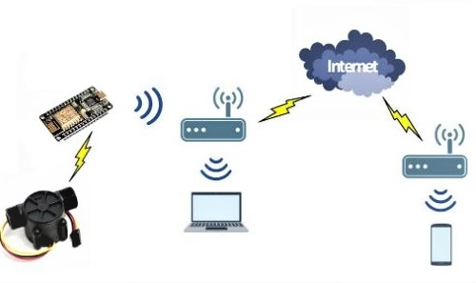

Block diagram

**PROBLEM DEFINITION**

The problem at hand is the inefficient utilization of water resources in public spaces, specifically parks and gardens, leading to excessive water consumption, increased operational costs, and potential environmental repercussions.

**Excessive Water Consumption:** Public parks and gardens often employ conventional irrigation methods that do not adapt to changing environmental conditions, resulting in the overuse of water resources.

**Lack of Data-Driven Decision-Making:** There is a lack of real-time data collection and analysis capabilities, hindering the ability to make informed decisions regarding water management.

**Environmental Impact:** The excessive use of water in public outdoor spaces can contribute to ecological imbalances, negatively affecting local ecosystems and potentially depleting water sources.

**Operational Costs:** High water consumption in these areas places a strain on municipal budgets, leading to increased water expenses and maintenance costs.

**REQUIRED ELEMENTS**

**IoT sensors:**

These sensors can measure water flow in taps and pipes in public places and other locations. They are connected to the internet, which allows them to be used for monitoring water.

**Gateway for IoT:**

This is the central hub that collects data from the sensors and upload it to the cloud for process.

**Cloud:**

It is used for data storing, processing data, and storage. It is used for managing the data on your device.

**Platform:**

A platform for real-time access for water consumption and collecting data from parks and gardens in websites or mobile applications.

**PROJECT GOALS**

The primary goal of this project is to achieve a significant reduction in water consumption in public parks and gardens while simultaneously maintaining or enhancing the quality, aesthetics, and functionality of these spaces. This reduction should be achieved through the implementation of sustainable and innovative water management practices and technologies.

**Reduce Water Consumption**: Decrease the overall water usage in public parks and gardens by a targeted percentage (e.g., 25%) within a defined timeframe.

**Optimize Cost Efficiency**: Lower operational costs related to water bills and maintenance expenses through more efficient water utilization, contributing to the financial sustainability of public spaces.

**Maintain or Improve Aesthetics**: Ensure that the reduction in water consumption does not compromise the attractiveness and functionality of public parks and gardens, but rather enhances their long-term appeal.

**Educate and Engage**: Engage with the community, park visitors, and relevant stakeholders to raise awareness about responsible water usage and involve them in the conservation efforts.

**Establish Monitoring and Reporting**: Implement real-time monitoring and reporting systems to track water consumption, savings, and environmental benefits, providing transparency and accountability.

**Serve as a Model**: Establish the project as a model for sustainable water management in public spaces, encouraging other municipalities and organizations to adopt similar practices.

By achieving these project goals, we aim to create more sustainable, environmentally responsible, and cost-effective public parks and gardens that continue to provide recreational and aesthetic benefits for the community while contributing to the conservation of valuable water resources.

**IoT DEVICE DEVELOPMENT:**

**ESP32 development board**

It is a versatile microcontroller with built in Wi-Fi and Bluetooth capabilities, making it an ideal tool for developing new applications. This system provides a high level of security and privacy protection, as well as a low cost solution to the installation of sensors and monitoring devices.

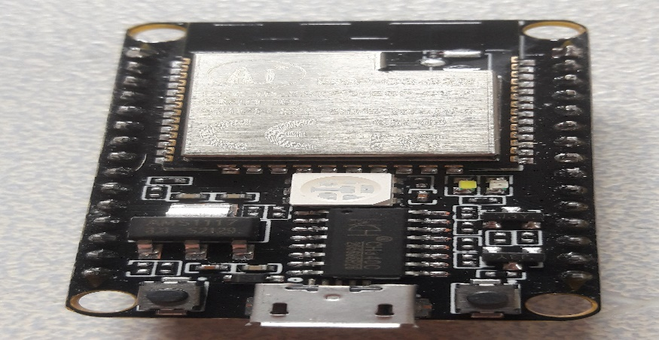

ESP32 processor

**Sensors**

The YF-S201 is the water flow sensor works on Hall Effect principle that can be used to monitor the flow of water help you determine if your water supply is running at optimal levels. It is also a great way to track water usage, which has working range of 1-30L/min. The size is 1/2 BSP which is enough for water usage in parks and garden. We can also use different based on the size of the water supply. This will save us time and money by saving energy.



YS-S201 sensor with ESP32 processor

**Power supply**

The stable power supply should ensured for ESP32 and sensors. Battery powered solution are possible, but they needed to replaced periodically. Considering power efficiency, we can use ac supply from the power lines or we can use power from solar panel placed in lights in the parks and garden.

**Enclosure**

The electronic components should be protected from environmental factors with weatherproof and suitable for outdoor use.

**SOFTWARE REQUIRED:**

**Select a Development Environment :**

Using the Arduino IDE with the ESP32 core installed, PlatformIO, or other IDEs that support the ESP32 platform.

**Wi-Fi connectivity:**

Configuring the ESP32 to connect to a Wi-Fi network so that it can transmit data to the cloud platform.

**Sensor Data Reading:**

Implementing code to read data from water flow sensor. So that it can show water consumption.

**Set Up Your Development Environment:**

Installing the necessary software, including the IDE, ESP32 board support, and any required libraries or extensions.

**Write Firmware :**

This code should include:

Initialization and configuration of the ESP32, including Wi-Fi or other connectivity options.

Code to read data from sensors.

Logic for data processing and decision-making based on sensor data.

Code for communication protocols (e.g., MQTT, HTTP) to transmit data to a central server or cloud platform.

Error handling and logging mechanisms for troubleshooting.

Power management strategies to optimize energy usage, especially if the device is battery-powered.

**Sensor Integration:**

Interface with sensors by utilizing appropriate libraries or implementing custom sensor drivers if necessary.

Calibrate and test sensors to ensure accurate data collection.

**Communication Protocols:**

Implement communication protocols to send data from the ESP32 to your central server or cloud platform. MQTT and HTTP are commonly used protocols for IoT communication.

Secure communication by using encryption and authentication mechanisms if required.

**Data Handling and Storage:**

Develop code for data storage and management. This may include storing data locally on the device, sending it to a database, or processing it in real-time.

**User Interface:**

IoT device requires a user interface, design and implement it. This could be a web-based dashboard, a mobile app, or a simple display on the device itself.

**Testing and Debugging:**

Thoroughly testing the firmware on the ESP32 device, simulating different scenarios and edge cases. Use debugging tools and techniques to identify and fix issues in the code.

**Integration with IoT Platform:**

Using an IoT platform or cloud service, integrate the ESP32 device with the platform's APIs and services.

**Deployment:**

Deploy the firmware to ESP32 devices in the field, ensuring they are properly configured and connected to the network.

**Maintenance and Updates:**

Plan for maintenance and updates of IoT devices' firmware, especially to make improvements, fix bugs, or enhance functionality over time.

**Monitoring and Analytics:**

Set up monitoring and analytics tools to track the performance and health of the deployed devices. This can help with troubleshooting and optimizing operations.

Software development for IoT devices, especially those based on the ESP32 processor, involves careful planning, coding, testing, and ongoing maintenance to ensure the reliability and effectiveness of solution.



Block diagram of ESP32 processor sharing data

**ANTICIPATED RESULTS:**

**Water Conservation:** Reduced water consumption through efficient irrigation practices and data-driven decisions, leading to water conservation in public spaces.

**Cost Savings:** Lower operational costs for parks and gardens due to reduced water bills, maintenance expenses, and improved resource allocation.

**Cost Savings:** Lower operational costs for parks and gardens due to reduced water bills, maintenance expenses, and improved resource allocation.

**Environmental Benefits:** Preservation of local ecosystems and reduction of environmental impact by preventing over-irrigation and water wastage.

**Improved Sustainability:** Enhanced sustainability of public spaces, aligning with environmental goals and demonstrating responsible water management.

**Data-Driven Insights:** Access to real-time and historical data on soil moisture, weather conditions, and water usage, enabling better-informed decisions.

**Efficient Resource Allocation:** Optimization of staff time and resources, as maintenance teams can focus efforts where and when they are needed most.

**User Satisfaction:** Enhanced park and garden aesthetics and usability due to healthier plant life and improved overall conditions, leading to increased visitor satisfaction.

**Remote Monitoring and Control:** Remote monitoring and control capabilities, allowing staff to adjust irrigation settings and respond to issues without being on-site.

**Long-Term Sustainability:** A foundation for long-term sustainability practices in managing public spaces, setting a positive example for responsible water use.

**Scalability:** A scalable solution that can be applied to multiple public spaces, parks, and gardens within a municipality or region.

**Data-Driven Decision-Making:** Insights from data collected by IoT devices can inform future landscaping and maintenance decisions, optimizing resources over time.

**Compliance and Reporting:** Compliance with water conservation regulations and the ability to generate reports on water usage and savings, which can be valuable for regulatory and budgetary purposes.

**Public Awareness:** Raising public awareness about water conservation and environmental responsibility through educational initiatives and transparent reporting.

**Adaptability and Resilience:** Building an adaptable system that can respond to changing weather patterns and environmental conditions, ensuring resilience in the face of climate change.

**Reduced Water Waste:** Minimized water waste through the prevention of over-irrigation, reducing the strain on local water resources.

These expected outcomes reflect the multifaceted benefits of implementing an IoT-based solution for water consumption optimization in public spaces. The project aims to strike a balance between

environmental responsibility, cost-effectiveness, and improved public amenity. Successful implementation can lead to a more sustainable and efficient use of resources in these areas.